Transmission Media

Guided or Wired
Unguided or wireless

Twisted Pair Cable
Microwave

Co- axial Cable
Infraced
Radio wave
Optical Fiber Cable

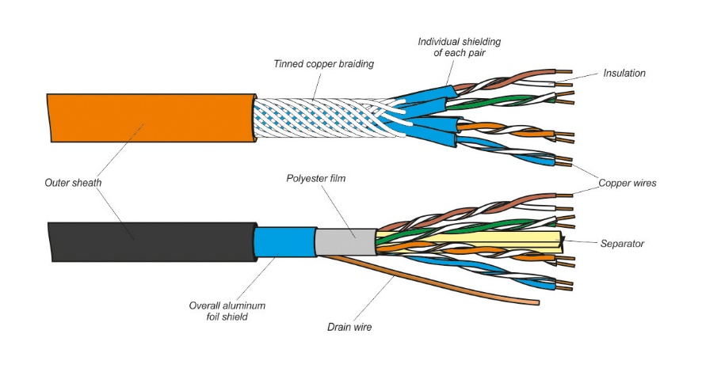
Twisted Pair Cable :- A twisted-pair cabling system is a cable consisting of one or several pairs of copper wires. These wires are twisted together and around each other and are insulated with a dielectric polymeric compound. Twisting helps minimize electromagnetic radiation and resists external interference.

* Twisted pair Cable are two Type

1. UTP ( Usheilded Twisted pair )
2. STP ( Shilded Twisted Pair )

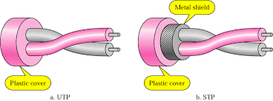
Coaxial Cable :- A coaxial cable is an electrical cable with a copper conductor and an insulator shielding around it and a braided metal mesh that prevents signal interference and cross talk. Coaxial cable is also known as coax.
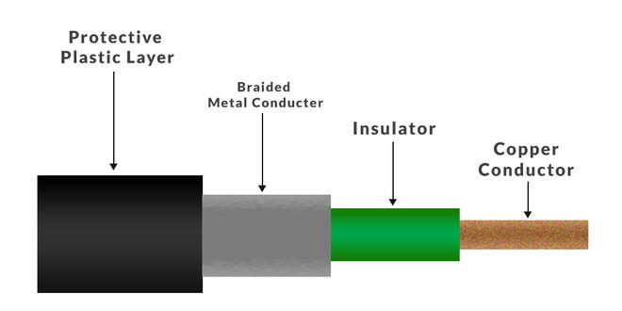

Advantages :-

- Coaxial cables support high bandwidth.
- It is easy to install coaxial cables.
- coaxial cables have better cut-through resistance so they are more reliable and durable.
- Less affected by noise or cross-talk or electromagnetic inference.
- Coaxial cables support multiple channels.

